**GROUP ASSIGNMENT**

**INTAKE CODE: UCDF2307ICT(SE)**

**MODULE CODE:** AICT004-4-2

**MODULE NAME:** OPERATING SYSTEM AND COMPUTER ARCHITECTURE

**LECTURER:** LAI CHEW PING

**GROUP TUTORIAL:** LAB-30

**TITLE:** [IMPLEMENTING SOLUTIONS TO BUSINESS PROBLEMS](https://study.com/academy/lesson/implementing-solutions-to-business-problems.html)

**SUBMISSION DATE:** 1 MARCH 2024

|  |  |
| --- | --- |
| **GROUP MEMBERS NAME** | **TP NUMBER** |
| 1. MAH ZHENG YANG (LEADER) | TP076666 |
| 1. CHEK KA NIC | TP074894 |
| 1. CHONG WEI JIE | TP076546 |

**Table of Contents**

**Database Schema** 3

**SQL-Data Definition Language (DDL)** 5

**SQL-Data Manipulation Language (DML)** 13

**Workload Matrix** 15

# **Database Schema**

ERD

Database Diagram

# **SQL-Data Definition Language (DDL)**

Tables

Chef

Contact

Cook

Delivery

Feedback

Worker

Food

Manager



Member

Order

Payment

ShoppingCart

Creating Tables

Inserting Values

# **SQL-Data Manipulation Language (DML)**







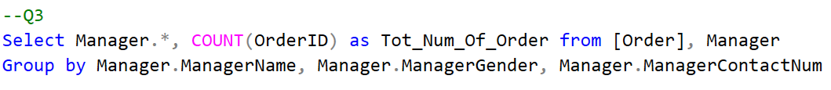



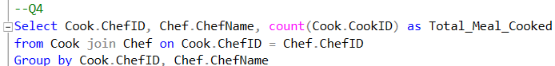

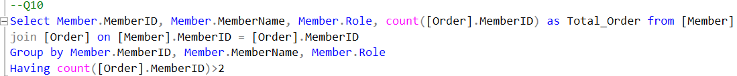



# **Workload Matrix**

|  |  |  |  |  |  |
| --- | --- | --- | --- | --- | --- |
| **Part** | **Component** | **Student 1 Name:**  Mah Zheng Yang | **Student 2 Name:**  Chek Ka Nic | **Student 3 Name:**  Chong Wei Jie | **Total** |
| **2** | Database Schema | 80% | 10% | 10% | **100%** |
| **2** | DDL | 10% | 10% | 80% | **100%** |
| **2** | DML | 10% | 90% | 0% | **100%** |